Name ______________________________

The Number System (6.NS.5)

Suzanne keeps track of her company’s gains and losses. This table shows the gains and losses for three months.
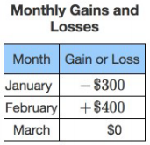
Based on the data in the table, which statements are true?

Choose yes or no | Explain your thinking
A. -$300 represents a loss of $300

Yes or No
B. -$300 represents a gain or $300

Yes or No
C. $0 represents a gain

Yes or No
D. $0 represents a loss

Yes or No
E. $0 represents no gain and no loss

Yes or No
F. +$400 represents a loss of $400

Yes or No
G. +400 represents a gain of $400

Yes or No

Source: PARCC Spring 2018 Grade 6 Released Items https://parcc-assessment.org/wp-content/uploads/2018/08/Math_2018_Released_Items/Grade06/Grade-6-Math-Item-Set-2018.pdf

