Name ______________________________

Arithmetic with Polynomials & Rational Expressions (A.APR.1)

The diagram represents a right rectangular prism with dimensions labeled as algebraic expressions.
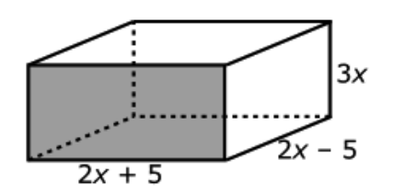
Which of these expressions represents the volume of the prism?
Select all that apply.

Statement | Yes or No | Explain your thinking
7x

4x² - 25

12x³- 75x

3x(4x² – 25)

(2x + 5)(6x² – 15x)

12x³ + 60x³ + 75x

12x³ - 30x³ + 10x – 25

Source:
https://assessmentresource.org/wp-content/uploads/2019/07/Integrated_Math_2_EOY_Item_Set.pdf
Integrated Math II EOY 2015, Item M40286

