Name ______________________________

Similarity, Right Triangles, and Trigonometry (G.SRT.2)
The diagram shows two quadrilaterals graphed on a coordinate plane. What transformation on quadrilateral 1 can be used to verify that it is similar to quadrilateral 2.
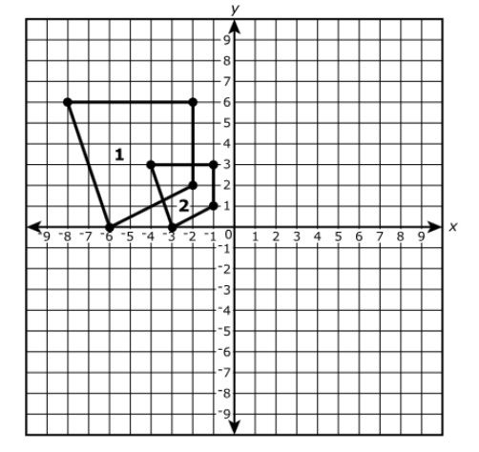

Statement | Yes or No | Explain your thinking
A dilation by a scale factor of ½ centered at the origin.

A dilation by a scale factor of ½ centered at (-6.0).

A dilation by a scale factor of ¾ centered at the origin.

A dilation by a scale factor of 2 centered at the origin.

Source: PARCC Spring 2017 Geometry Released Items
https://parcc-assessment.org/wp-content/uploads/2018/01/MathReleasedItems/Geometry-Item-Set-2017.pdf

