Name ______________________________

Measurement and Data (3.MD.5)

Which figure correctly models how square units can be used to find the total area?

Statement | Yes or No | Explain your thinking
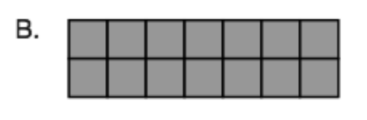

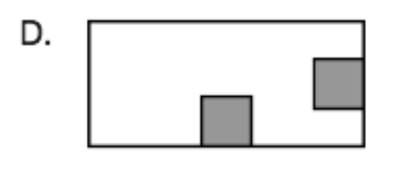

Source:
https://assessmentresource.org/wp-content/uploads/2019/08/Grade-3-Math-Item-Set-2018_20181029.pdf
Math Spring 2018, item VH055538

