Name ______________________________

Measurement and Data (3.MD.8)

Five rectangles are shown.
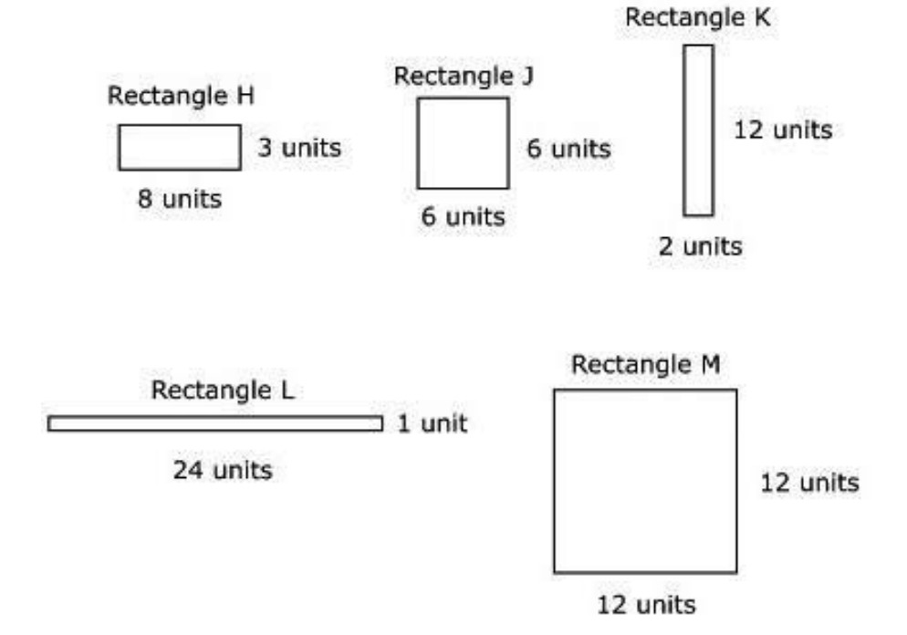
Which rectangles have an area of 24 square units and a perimeter greater than 23 units?
Select the two correct answers.

Statement | Yes or No | Explain your thinking
- Rectangle H

- Rectangle J

- Rectangle K

- Rectangle L

- Rectangle M

Source:
https://assessmentresource.org/wp-content/uploads/2019/08/Grade-3-Math-Item-Set-2018_20181029.pdf
Math Spring 2018, item M00007P

