Name ______________________________

Number and Operations - Fractions (3.NF.1)

Adam ate $\frac{2}{3}$ of a pancake. Which model shows how much Adam ate?

Statement | Yes or No | Explain your thinking
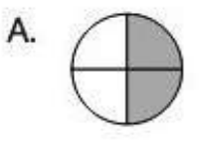

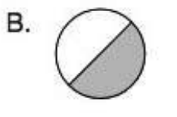

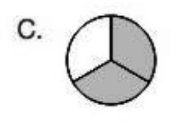

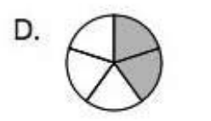

Source:
https://assessmentresource.org/wp-content/uploads/2019/08/Grade-3-Math-Item-Set-2018_20181029.pdf
Math Spring 2018, item M00005P

