Name ______________________________

Number and Operations - Fractions (3.NF.2)

Which number line has a point plotted to represent $\frac{5}{2}$ ?

Statement | Yes or No | Explain your thinking
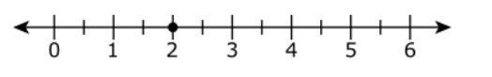

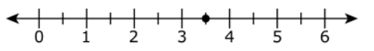

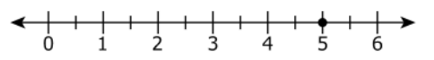

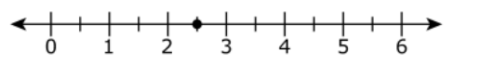

Source:
http://resources.newmeridiancorp.org

