Name ______________________________

Number and Operations - Fractions (3.NF.3a)

Which models have the same fractional part shaded as Figure Y? Each model is the same size and the same shape as Figure Y.
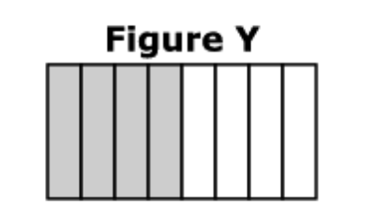
Select the two correct answers.

Statement | Yes or No | Explain your thinking
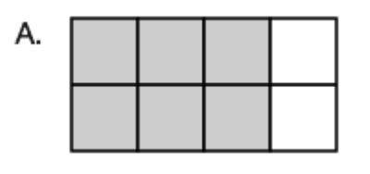

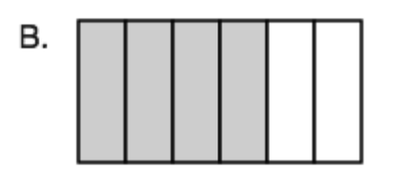

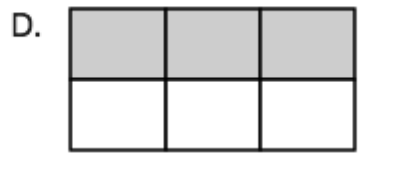

Source:
https://assessmentresource.org/wp-content/uploads/2019/08/Grade-3-Math-Item-Set-2018_20181029.pdf
Math Spring 2018, item M01190

