Name ______________________________

Number and Operations in Base Ten (4.NBT.2)

Two pairs of numbers are shown. The symbol needed to compare the two numbers is missing from each box.

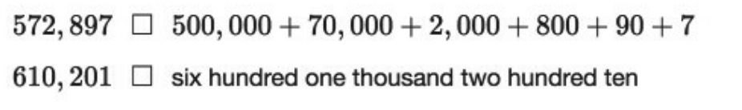

Which two symbols should be placed into the boxes to correctly compare the two pairs of numbers?

Statement | Yes or No | Explain your thinking
- < , =

- = , =

- = , >

- < , >

Source:
https://assessmentresource.org/wp-content/uploads/2019/08/Grade-4-Math-Item-Set-2018.pdf
Grade 4 – Spring 2018, Item M03184P

