Name ______________________________

Number and Operations - Fractions (4.NF.3a)

Which expression represents a total distance of $\frac{3}{10}$ of a meter?

Statement | Yes or No | Explain your thinking
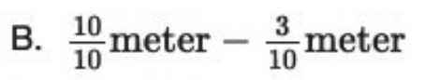

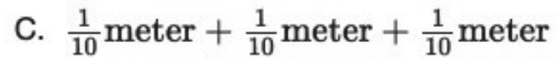

Source:
https://assessmentresource.org/wp-content/uploads/2019/08/Grade-4-Math-Item-Set-2018.pdf
Grade 4 – Spring 2018, Item M01450

