Name ______________________________

Ratios and Proportional Relationships (7.RP.2)

Which graphs represent a proportional relationship between x and y?

Choose yes or no | Explain your thinking
A.
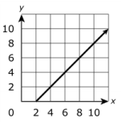
Yes or No

B.
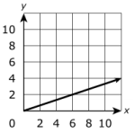
Yes or No

C.
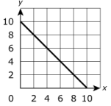
Yes or No

D.
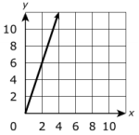
Yes or No

E.
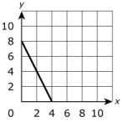
Yes or No

F.
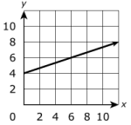
Yes or No

Source: PARCC Spring 2017 Grade 7 Released Items https://parcc-assessment.org/wp-content/uploads/2018/01/MathReleasedItems/Grade-7-Math-Item-Set-2017.pdf

