Name ______________________________

Ratios and Proportional Reasoning (7.RP.2d)

The graph shows the relationship between the number of pounds of potatoes (x) and the total cost of the potatoes (y).
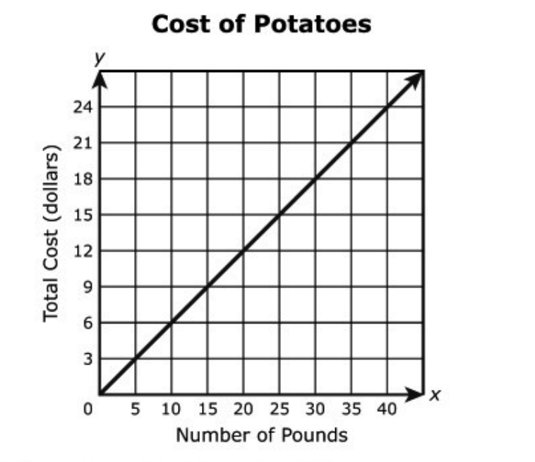

Which statements about the points on the graph of the relationship are correct?
Select each correct statement.

Choose yes or no | Explain your thinking
A. The point (1, 0.60) means that 1 pound of potatoes costs $0.60.

Yes or No

B. The point (12, 7.20) means that 12 pounds of potatoes costs $7.20 per pound.

Yes or No

C. The point (20, 12) means that 12 pounds of potatoes costs $20.00 per pound.

Yes or No

D. The point (25, 15) means that 15 pounds of potatoes costs $25.00.

Yes or No

E. The point (30, 18) means that 18 pounds of potatoes costs $30.

Yes or No

F. The point (40, 24) means that 40 pounds of potatoes costs $24.

Yes or No

Source: https://assessmentresource.org/wp-content/uploads/2019/08/Grade-7-Math-Item-Set-2018.pdf
Grade 7 – 2018, Item M25121

