Name ______________________________

Geometry (8.G.1c)

Parallelogram WXYZ is shown on the coordinate plane.
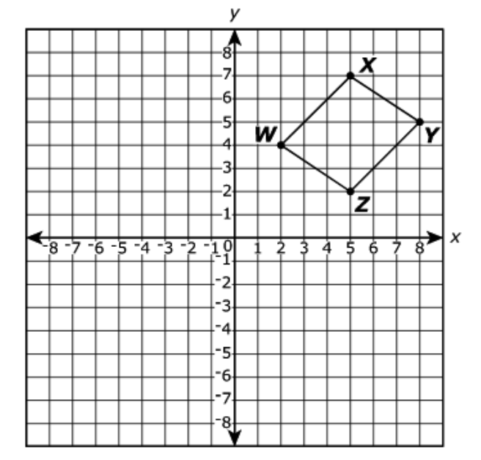
Parallelogram W’X’Y’Z’ (not shown) is the reflection of parallelogram across the y-axis. Which statement is true?

Choose yes or no | Explain your thinking
A. $\overline{W'X'}$ is parallel to $\overline{W'Z'}$

Yes or No

B.$\overline{W'X'}$ is parallel to $\overline{Z'Y'}$

Yes or No

C. $\overline{W'X'}$ is perpendicular to $\overline{W'Z'}$

Yes or No

D. $\overline{W'X'}$ is perpendicular to $\overline{Z'Y'}$

Yes or No

Source: https://assessmentresource.org/wp-content/uploads/2019/08/Grade-8-Math-Item-Set-2018.pdf
Grade 8 – 2018, Item VH010947

