Name ______________________________

Congruence (G.CO.3)

Octagon PQRSTVWZ is a regular octagon with its center at point C.
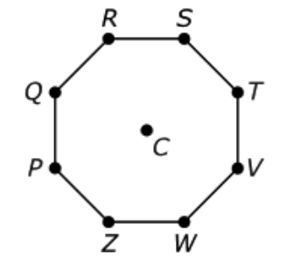
Which transformation will map octagon PQRSTVWZ onto itself?
Select each correct transformation.

Statement | Yes or No | Explain your thinking
Reflecting over $\overline{QV}$

Reflecting over $\overline{RW}$

Reflecting over $\overline{TZ}$

Rotating 45° clockwise around point Z

Rotating 135° clockwise around point C

Rotating 90° counterclockwise around point C

Source:
https://assessmentresource.org/wp-content/uploads/2019/07/Integrated_Math_1_EOY_Item_Set-1.pdf
HS Integrated Math I 2015 EOY, Item VF798931

