Name ______________________________

Congruence (G.CO.6)

Statement | Yes or No | Explain your thinking
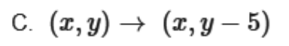

Source:
https://assessmentresource.org/wp-content/uploads/2019/07/Integrated_Math_1_EOY_Item_Set-1.pdf
Integrated Math I EOY, Spring 2015, Item VF891370

