Choice Board
Grade 6 Rates and Ratios
Task 1  6.RP.1  Given the Tape Diagram, write a ratio and a word problem to go along with the picture.  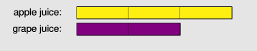  Source: Progressions for the CCSSM  https://commoncoretools.files.wordpress.com/2012/02/ccss_progression_rp_67_2011_11_12_corrected.pdf | Task 2  6.RP.2  Yellow and blue paint were mixed in a ratio of 5 to 3 to make green paint. After 14 liters of blue paint were added, the amount of yellow and blue paint in the mixture was equal. How much green paint was in the mixture at ﬁrst?  Represent this multi-step problem with two pairs of tape diagrams.  Source: Progressions for the CCSSM  https://commoncoretools.files.wordpress.com/2012/02/ccss_progression_rp_67_2011_11_12_corrected.pdf | Task 3  6.RP.1  Engage NY Lesson  Module 1 Lesson 7  Example 1 and 2  Handout Below  Source: EngageNY  https://www.engageny.org/resource/grade-6-mathematics-module-1-topic-lesson-7/file/38521
Task 4  6.RP.3  Solve each problem and describe how the problems are similar and different.  - After a 20% discount, the price of a SuperSick skateboard is $140. What was the price before the discount?  - A SuperSick skateboard costs $140 now, but its price will go up by 20%. What will the new price be after the increase?  Source: Progressions for the CCSSM  https://commoncoretools.files.wordpress.com/2012/02/ccss_progression_rp_67_2011_11_12_corrected.pdf | Task 5  6.RP.1  Slimy Gloopy mixture is made by mixing glue and liquid laundry starch in a ratio of 3 to 2. How much glue and how much starch is needed to make 85 cups of Slimy Gloopy mixture?  Use a Tape Diagram to solve.  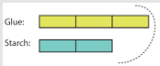  Source: Progressions for the CCSSM  https://commoncoretools.files.wordpress.com/2012/02/ccss_progression_rp_67_2011_11_12_corrected.pdf | Task 6  6.RP.3  A credit card company charges 17% interest on any charges not paid at the end of the month. Make a ratio table to show how much the interest would be for several amounts. If your bill totals $450 for this month, how much interest would you have to pay if you let the balance carry to the next month? Show the relationship on a graph and use the graph to predict the interest charges for a $300 balance.  Source: Kansas Department of Education  https://community.ksde.org/LinkClick.aspx?fileticket=J4xYrFOUWGM%3d&tabid=5646&mid=15542
Task 7  6.RP.2  If 2 pounds of beans cost $5, how much will 15 pounds of beans cost?  Show two different strategies to solve. | Task 8  6.RP.2  Approximate the cost for each egg.  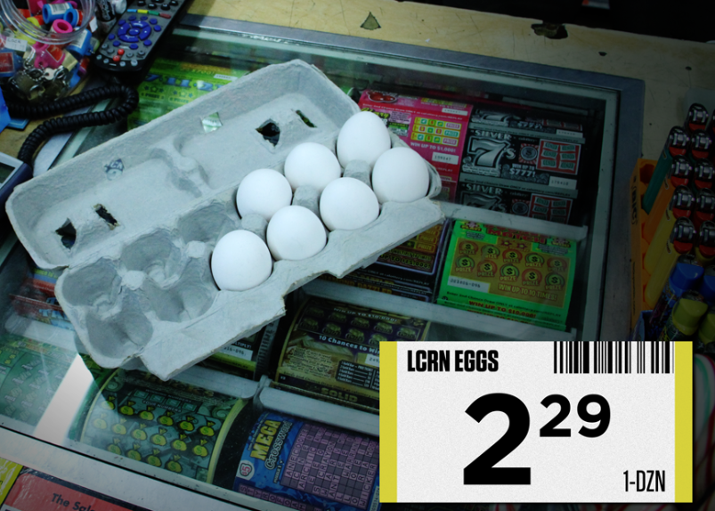 | Task 9  6.RP.3c  What is 6% of 250?  Solve with ratio and percent reasoning.  (decomposing, tape diagram or drawing)

Task 3 Handout
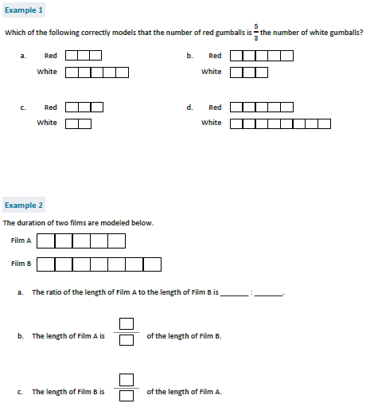

Task from EngageNY
https://www.engageny.org/resource/grade-6-mathematics-module-1-topic-lesson-7/file/38521

